3D Metalforge’s Additive Manufactured Parts Successfully Tested On-Board the ConocoPhillips Polar Tanker’s Endeavour Oil Tanker
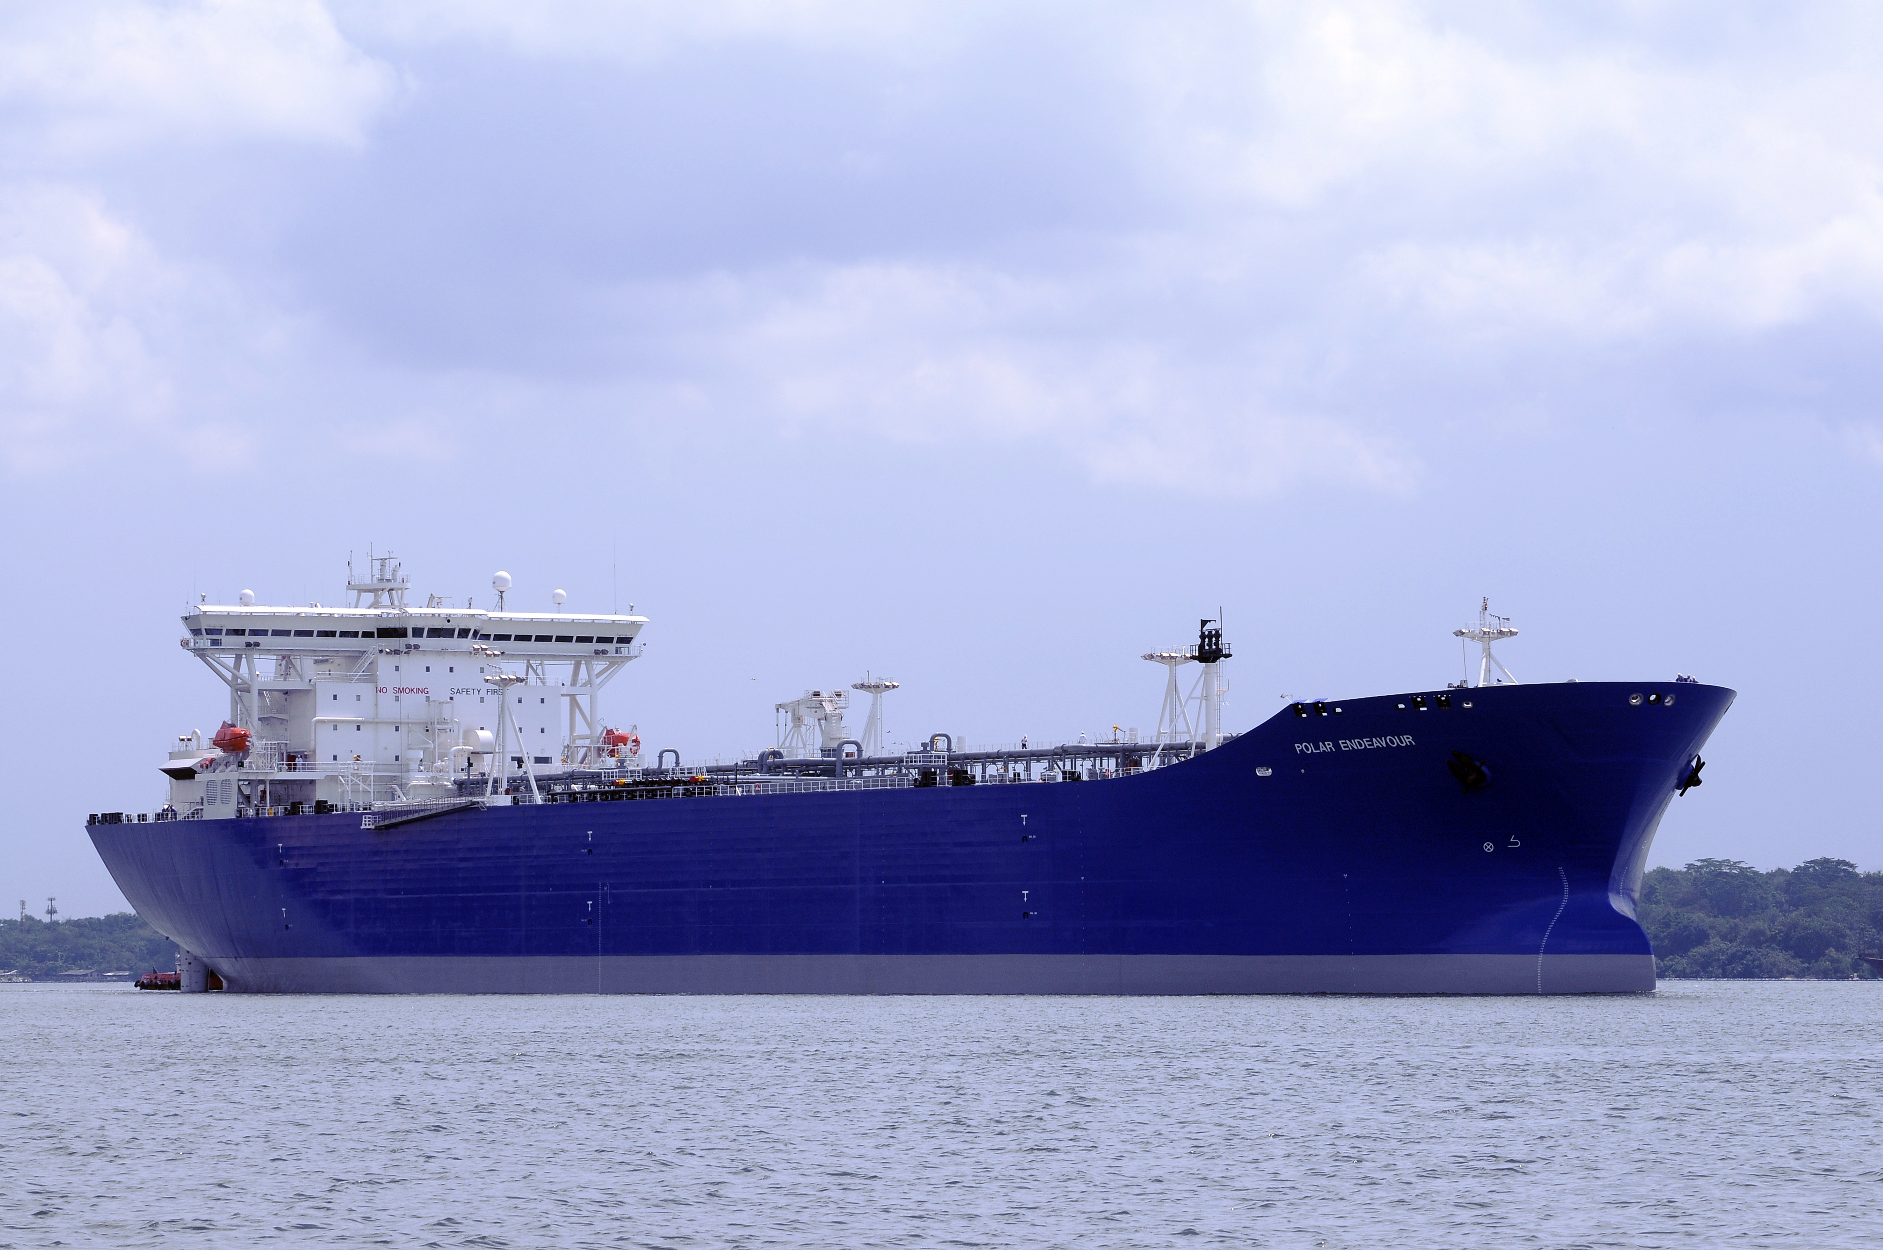
Houston, TX, November 2021: 3D Metalforge is pleased with the results of an industry leading Additive Manufacturing (AM) project led by multi-national firms ABS, ConocoPhillips Polar Tankers, Sembcorp Marine Ltd and 3D Metalforge. This pioneering AM project started in February 2021 where functional additive manufactured parts were fabricated, lab-tested and installed on-board the oil tanker Endeavour. Parts fabricated by AM, installed and in operation on the oil tanker by Sembcorp Marine for six months, have been retrieved, inspected by the vessel’s crew and remote surveyed by ABS, and have been validated to be in good working condition.
Sembcorp Marine Head of Research & Development Mr. Simon Kuik, said, “The success of this project augurs well for the adoption of AM in the marine industry. Through AM, Sembcorp Marine is able to customize parts for our customers and reduce material wastage and remove supply chain inefficiencies.
Image of the oil tanker Endeavour
“We are proud to work as a trusted partner, with companies like ABS, Sembcorp Marine and ConocoPhillips Polar Tankers to provide greater value through new and innovative manufacturing solutions, and to help meet changing component manufacturing, supply chain and sustainability challenges. The inspection and validation of these additively manufactured components support our belief in this technology and its application. This exposure to Additive Manufacturing’s capabilities will broaden its commercial applications and acceptance in the future,” said Mr. Matthew Waterhouse, 3D Metalforge Managing Director.
###

This announcement has been approved for release by the Managing Director of 3D Metalforge Limited.

For more information please contact:

Company enquiries Media enquiries
Matthew Waterhouse Bob Lytle
Managing Director Marketing Manager
info@3dmetalforge.com bob.lytle@3dmetalforge.com

ABOUT 3D METALFORGE
3D Metalforge (ASX: 3MF), founded in 2015, is a leading Additive Manufacturing (AM) company that supports a growing multinational industry-leading client base with their advanced proprietary 3D additive manufacturing systems. The Company offers a full range of in-house AM printing services from design and engineering, material advisory, diagnostics and testing, to printing and post-production certification to the latest industry and API standards. Its approach to industrial production, its proprietary processes and eco-friendly technology produce high-demand parts faster, better and more cost-effectively with less environmental impact and greater sustainability than conventional manufacturing.

